CHAPTER TWO
LITERATURE REVIEW
2.1 Introduction
This chapter reviews existing literature and similar systems for IoT-based smart energy monitoring. The Internet of Things (IoT) refers to a network of interconnected physical devices that are embedded with sensors, actuators, and communication hardware, enabling them to collect, exchange, and act upon data. The concept was firstpopularisedby Kevin Ashton in 1999 and has since evolved into a foundational technology paradigm (Ashton, 2009). Atzori et al. (2010) describe IoT as a global network infrastructure that links physical and virtual objects through interoperable communication protocols.
The IoT architecture is commonlycategorisedinto three layers: the perception layer (sensors and actuators), the network layer (communication protocols and gateways), and the application layer (data processing and user interfaces). In the context of energy monitoring, the perception layer comprises smartmetersand sensors that measure electrical parameters. The network layer transmits this data using protocols such as HTTP, MQTT, or WebSocket. The application layer processes andvisualisesthe data on dashboards for end-users (Gubbi et al., 2013).
IoT has found widespread application in smart homes, healthcare, agriculture, transportation, and energy management. The global IoT market is projected to reach $1.1 trillion by 2026 (Statista, 2024), with energy monitoring being one of the fastest-growing segments.

2.2 Review of Related Systems
This section reviews four existing IoT energy monitoring platforms. Each system is analysed in terms of its architecture, features, strengths, and weaknesses to identify the research gap that this project aims to address.
2.2.1 System 1: AWS IoT Core and AWS IoT Analytics
Overview: AWS IoT Core is a managed cloud service that allows connected devices to securely interact with cloud applications. AWS IoT Analytics provides data processing and visualisation capabilities for IoT data at scale. Together, they form a comprehensive industrial IoT platform.
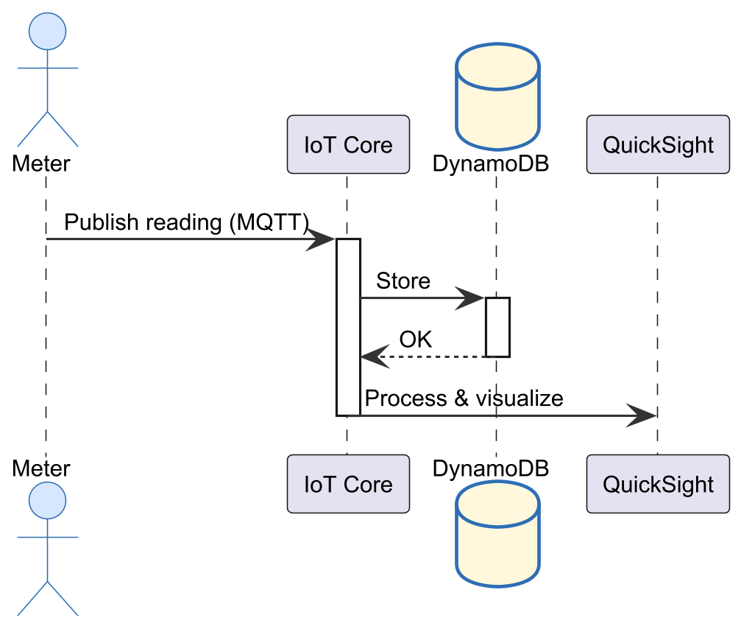
Figure 2.1: Context Diagram of AWS IoT Core
Context Model: The system operates in a cloud-centric context where smart meters, sensors, and actuators communicate with AWS IoT Core via MQTT. The cloud processes data and feeds it to analytics dashboards and third-party applications.
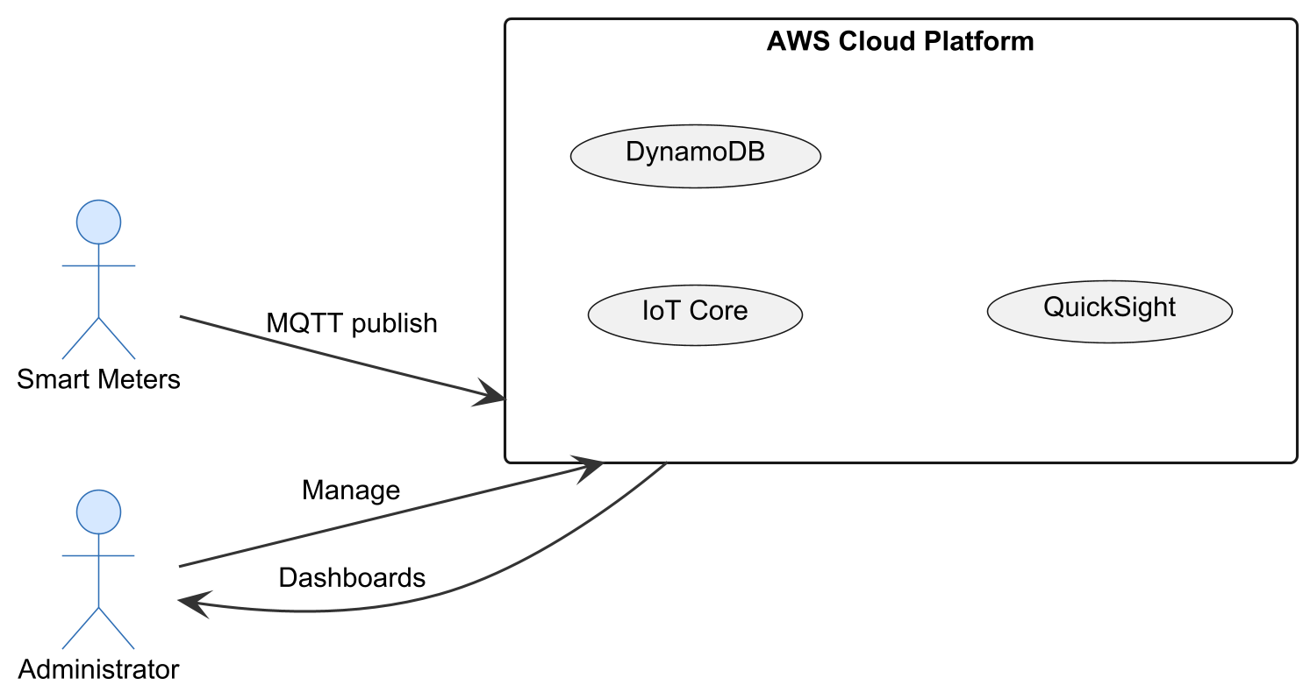
Figure 2.2: Sequence Diagram of AWS IoT Core
Interaction Model (Sequence): A smart meter publishes a reading to an MQTT topic. AWS IoT Core receives the message, invokes a rule to store data in DynamoDB, and triggers IoT Analytics for processing. The processed data is visualized on Quick-sight dashboards.
Structural Model: Key components include IoT Core (message broker), Device Shadow (state management), Rules Engine (data routing), DynamoDB (storage), IoT Analytics (processing), and Quick-sight(visualization).
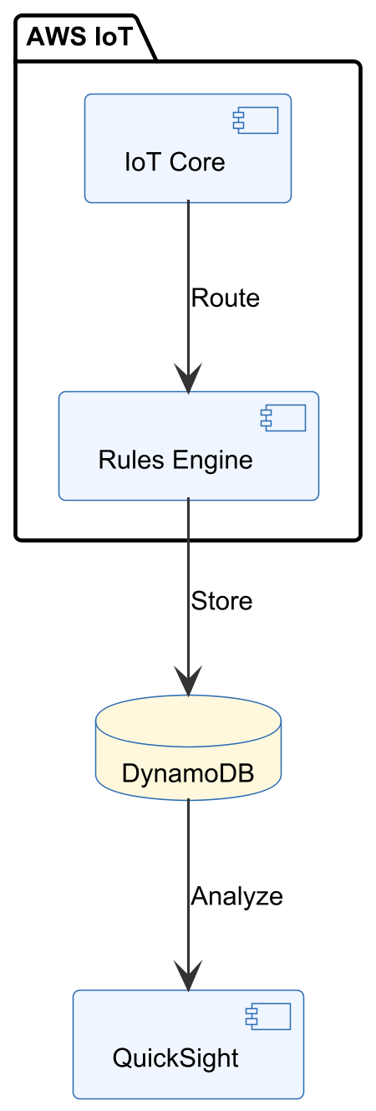
Figure 2.3: Structural Model of AWS IoT Core
Behavioural Model: The system continuously ingests data. When a reading exceeds a threshold, a CloudWatch alarm is triggered, sending an SNS notification.
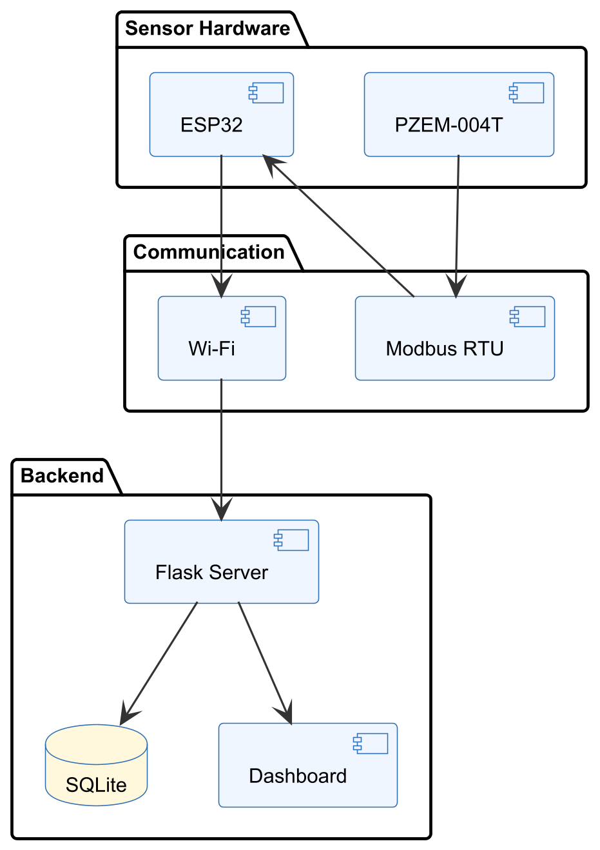
Figure 2.4: Behavioural Model of AWS IoT Core

1. DESCRIPTION OF SYSTEM (Features of the system):
Scalable cloud infrastructure supporting millions of devices
Built-in security with X.509 certificate authentication
Rule engine for data routing and transformation
Integration with AWS analytics, machine learning, and notification services
Pre-built dashboards via Amazon QuickSight
Development tools and environment: AWS Console, AWS CLI, MQTT client libraries, Python SDK (boto3).
2. REVIEW OF THE GOOD FEATURES
Enterprise-grade scalability and reliability
Comprehensive security features
Integration with a wide ecosystem of cloud services
Fully managed — no infrastructure maintenance
3. REVIEW OF THE BAD FEATURES
High cost at scale — pay-per-message and per-rule pricing
Complex setup — steep learning curve for beginners
Vendor lock-in — migration to other platforms is difficult
Requires constant internet connectivity
4. SUMMARY OF THE SYSTEM REVIEW: AWS IoT Core is a powerful enterprise solution but is overly complex and expensive for small-scale or educational projects. It requires cloud subscription and has a steep learning curve.
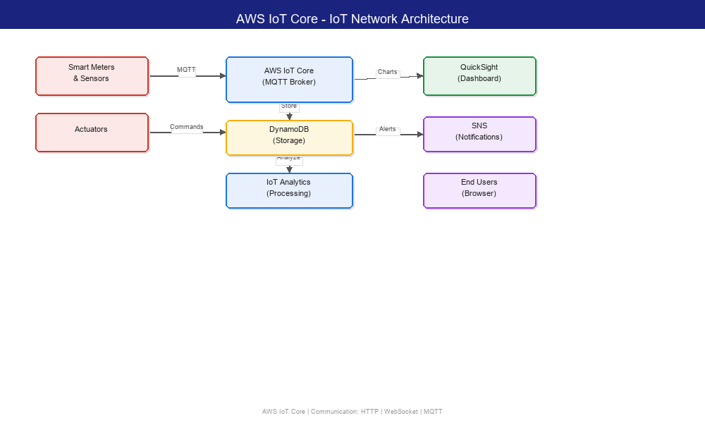
Figure 2.17: AWS IoT Core - IoT Network Architecture
2.2.2 System 2: openHAB
Overview: openHAB (open Home Automation Bus) is an open-source home automation platform written in Java. It integrates with over 200 different devices and protocols, including smart meters, thermostats, lighting systems, and energy monitoring devices.
Context Model: openHAB runs on a local server (e.g., Raspberry Pi or a PC) and communicates with IoT devices via bindings that implement various protocols (Modbus, MQTT, KNX, Z-Wave). Users access the system via a web UI or mobile app.
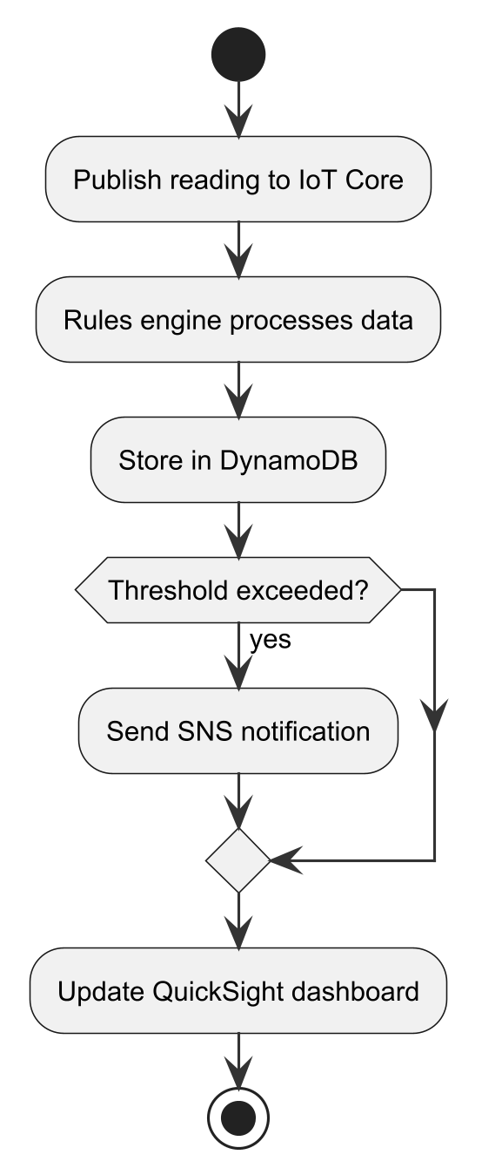
Figure 2.5: Context Diagram of openHAB
Interaction Model (Sequence): A sensor sends data to openHAB via an MQTT binding. The openHAB rule engine processes the data, updates the internal state model, and triggers rules if conditions are met (e.g., energy > threshold → send alert).
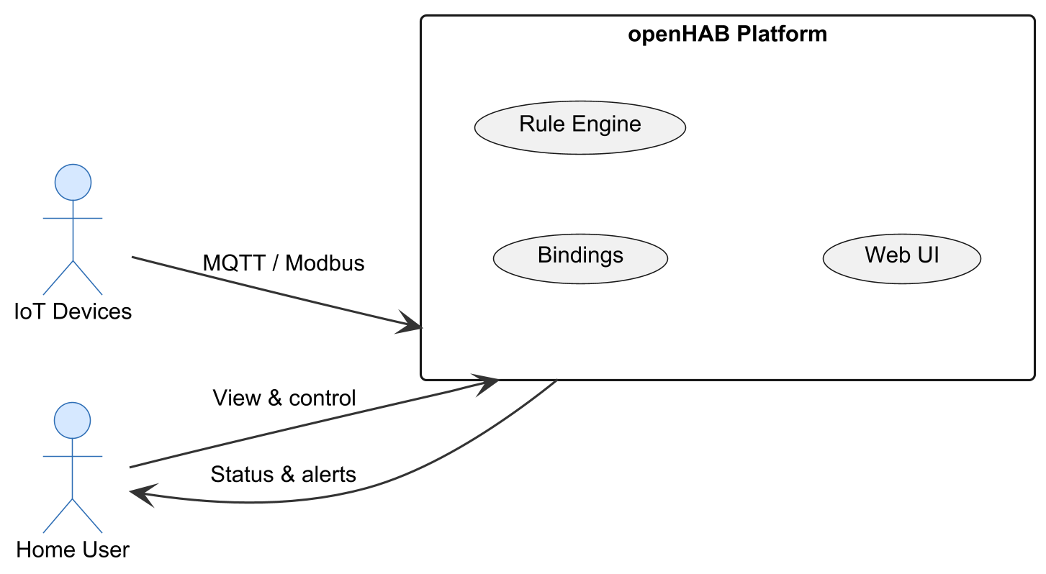
Figure 2.6: Sequence Diagram of openHAB
Structural Model: Core components include the openHAB runtime (OSGi-based), bindings (protocol adapters), the rule engine (DSL-based), persistence services (InfluxDB, RRD4j), and the UI layer (Basic UI, HABPanel, mobile apps).
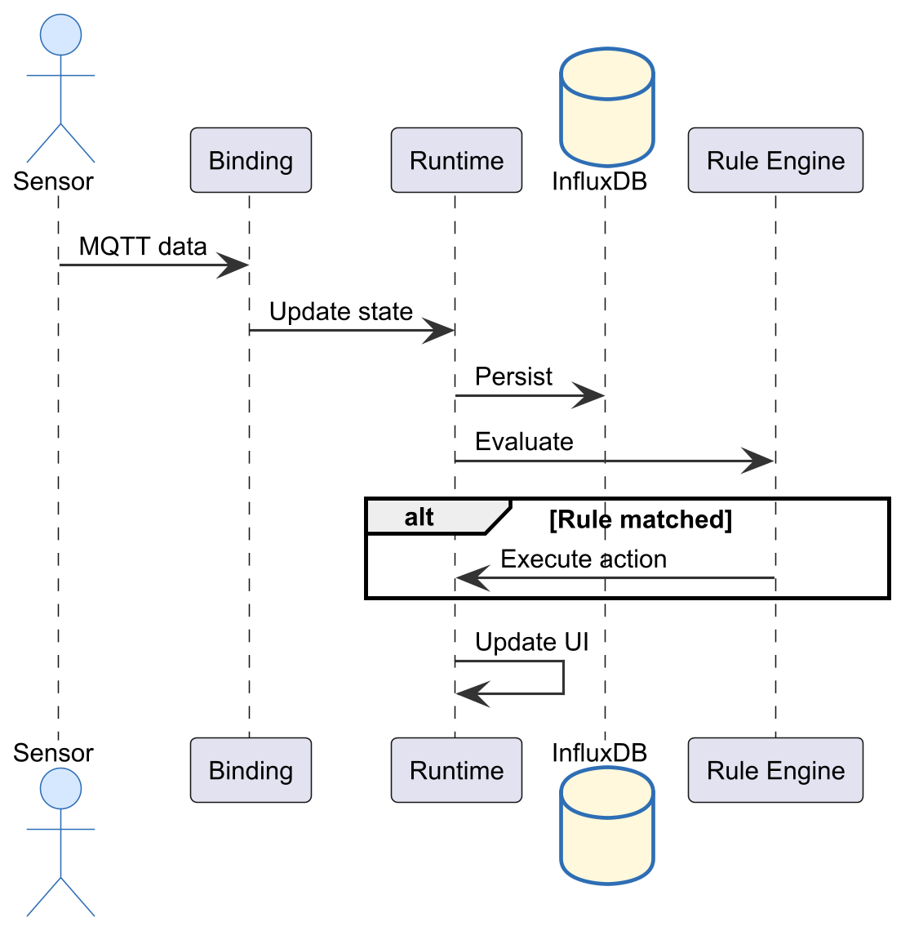Behavioral Model: The system reacts to state changes. When an energy sensor reading exceeds a defined threshold, a rule triggers an alert notification (email, push notification).
Figure 2.7: Structural Model of openHAB
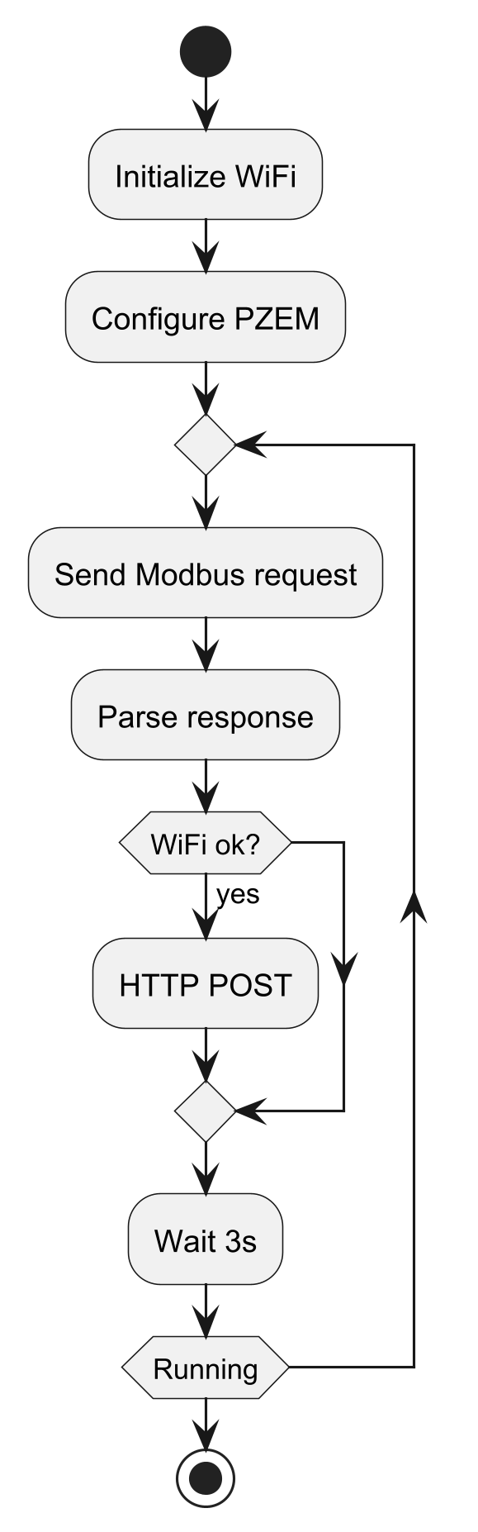
Figure 2.8: Behavioural Model of openHAB

1. DESCRIPTION OF SYSTEM (Features of the system):
Open-source and free (no licensing costs)
Support for 200+ devices and protocols
Local processing — no cloud dependency
Powerful rule engine with DSL
Mobile apps (iOS, Android)
Development tools and environment: Java, Eclipse SmartHome framework, Maven build tool, VS Code with openHAB extension.
2. REVIEW OF THE GOOD FEATURES
Truly open-source with active community
No recurring costs
Runs on low-cost hardware (Raspberry Pi)
Extensive protocol support
3. REVIEW OF THE BAD FEATURES
Steep learning curve for configuration
Uses Java, which is heavier than Python-based alternatives
Limited built-in data visualisation capabilities
Community-driven support — no official SLA
4. SUMMARY OF THE SYSTEM REVIEW: openHAB is a robust open-source solution ideal for home automation enthusiasts, but its complexity and Java dependency make it less suitable for a lightweight simulation project.
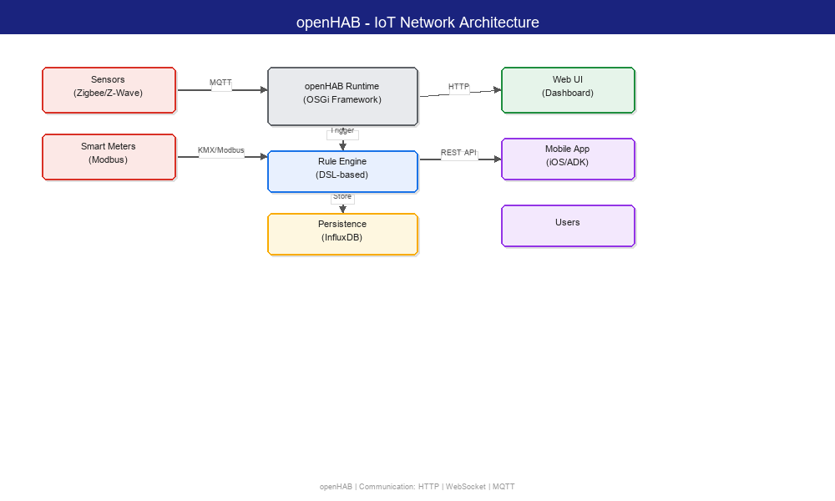
Figure 2.18: openHAB IoT Network Architecture
2.2.3 System 3: Blynk IoT Platform
Overview: Blynk is a low-code IoT platform that enables rapid development of IoT applications through drag-and-drop widget-based dashboards. It supports Arduino, ESP32, Raspberry Pi, and other popular microcontroller boards.
Context Model: Devices connect to the Blynk cloud server via Wi-Fi using the Blynk library. Users design dashboards in the Blynk mobile app by dragging widgets (gauges, charts, buttons) and binding them to virtual pins on the microcontroller.
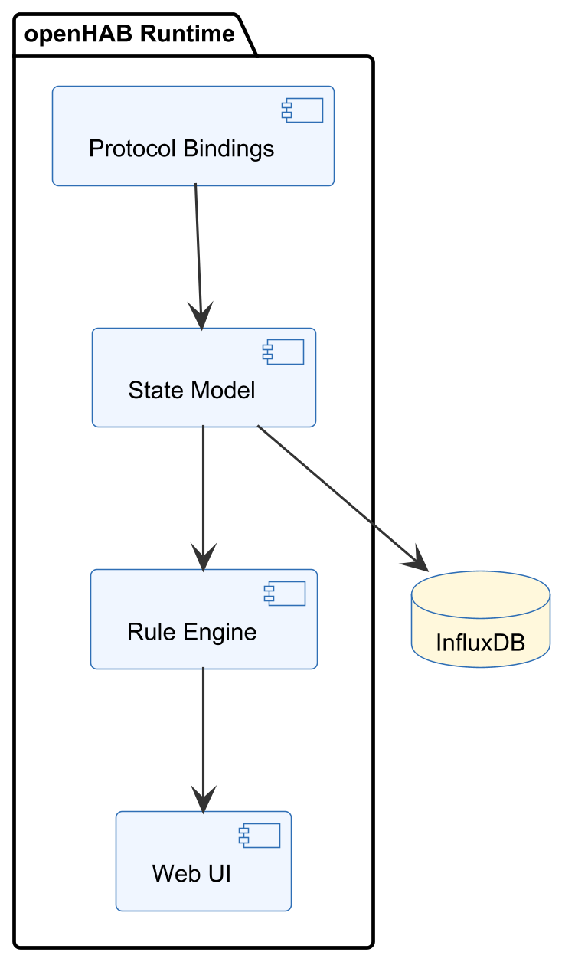
Figure 2.9: Context Diagram of Blynk
Interaction Model (Sequence): An ESP32 reads a sensor, sends the value to Blynk cloud via HTTP or MQTT. The cloud updates the widget state, and the mobile app reflects the change in real time.
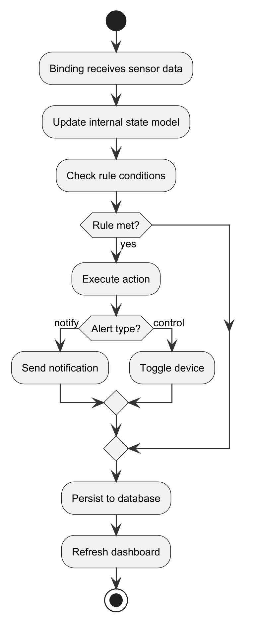
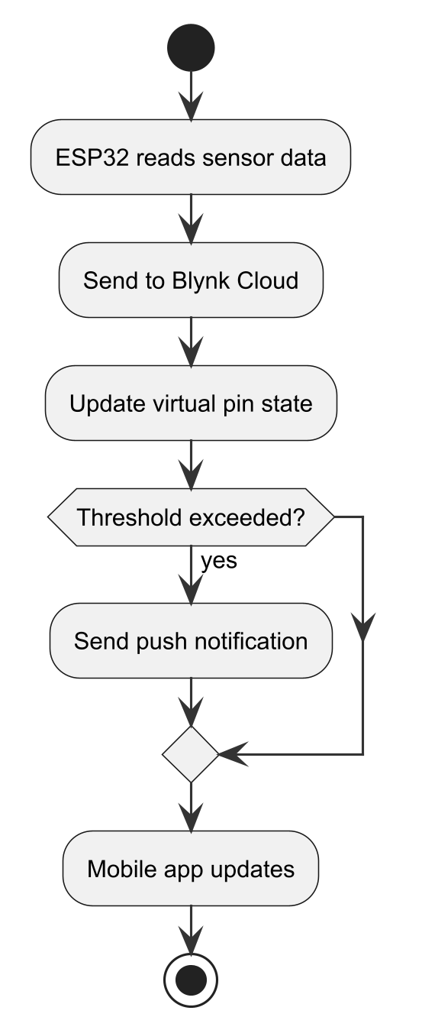
Figure 2.10: Sequence Diagram of Blynk
Figure 2.11: Structural Model of Blynk
Structural Model: Components include the Blynk library (firmware), Blynk cloud server, mobile app (iOS/Android), and virtual pins that map sensor data to UI widgets.
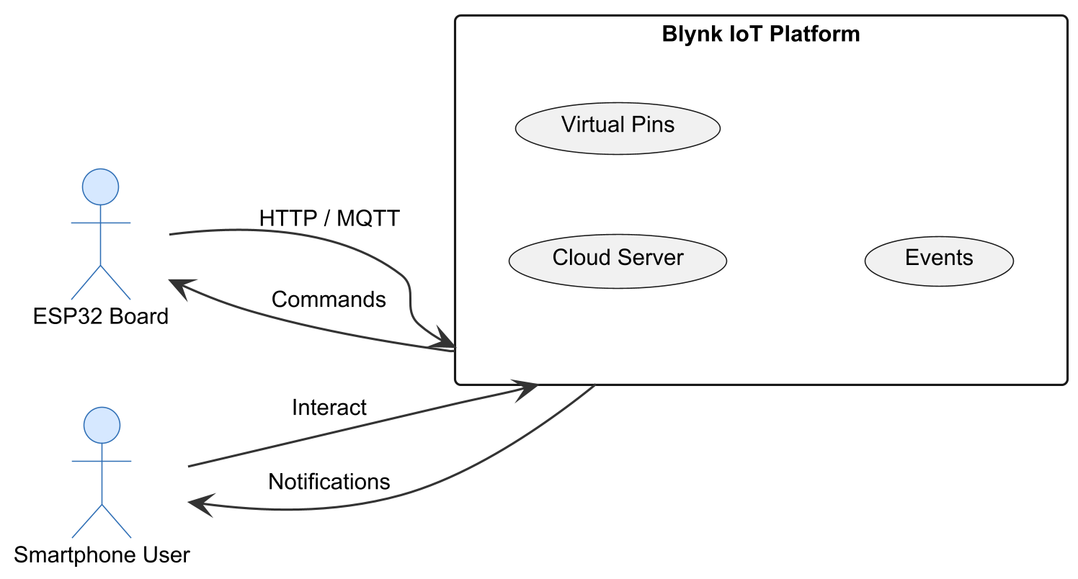
Figure 2.12: Behavioural Model of Blynk
Behavioural Model: The system continuously synchronises device data with cloud. Notifications are triggered via Blynk's event system when a value crosses a threshold.
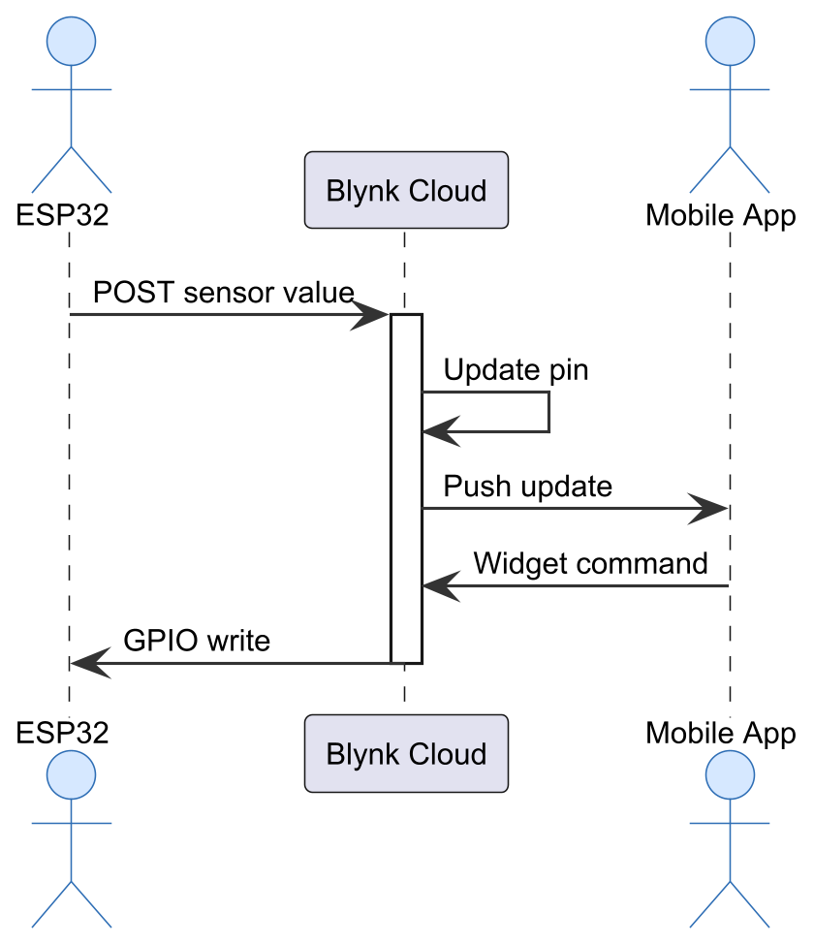
Figure 2.13: Features of Blynk
1. DESCRIPTION OF SYSTEM (Features of the system):
Drag-and-drop widget builder for dashboards
Cross-platform mobile app (iOS, Android)
Supports Arduino, ESP32, Raspberry Pi, and more
Built-in notification system (push, email)
Cloud-hosted — no server setup required
Development tools and environment: Arduino IDE, Blynk mobile app, Blynk library (C++).
2. REVIEW OF THE GOOD FEATURES
Extremely fast prototyping dashboards in minutes
No backend coding required
Works with popular low-cost hardware
3. REVIEW OF THE BAD FEATURES
Limited customisation— widgets are predefined
Cloud dependency — requires internet throughout
Free tier has device and data limits
No web dashboard (mobile-only)
4. SUMMARY OF THE SYSTEM REVIEW: Blynk is excellent for rapid IoT prototyping on mobile but lacks a web dashboard, has cloud dependency, and offers limited customisation— making it unsuitable for this project's desktop dashboard requirement.
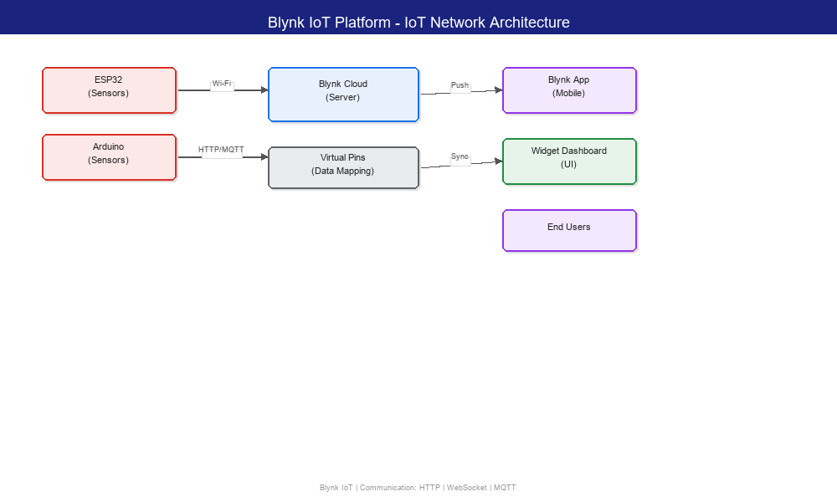
Figure 2.19: Blynk IoT Platform - IoT Network Architecture
2.2.4 System 4: ESP32 + PZEM-004T Energy Monitor
Overview: PZEM-004T is an AC energy monitoring module that measures voltage, current, power, frequency, power factor, and energy consumption. It communicates via Modbus RTU over serial. Combined with an ESP32 microcontroller, it forms a popular DIY smart energy monitoring solution.
Context Model: The PZEM-004T is connected in line with an AC load. It communicates with the ESP32 via TTL serial (Modbus). The ESP32 reads data and transmits it to a local server or cloud via Wi-Fi.
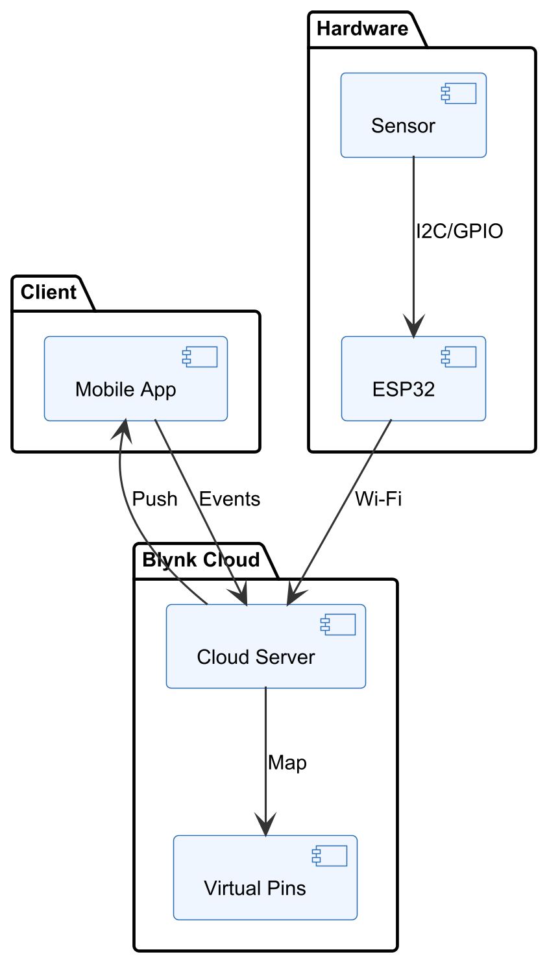
Figure 2.14: Context Diagram of ESP32 + PZEM-004T
Interaction Model (Sequence): ESP32 sends a Modbus request to PZEM-004T. PZEM responds with measured values. ESP32 parses the response and sends the data via HTTP POST to a web server.
Structural Model: Components include PZEM-004T (sensor module), ESP32 (microcontroller with Wi-Fi), a local server or cloud endpoint, and a dashboard forvisualisation.
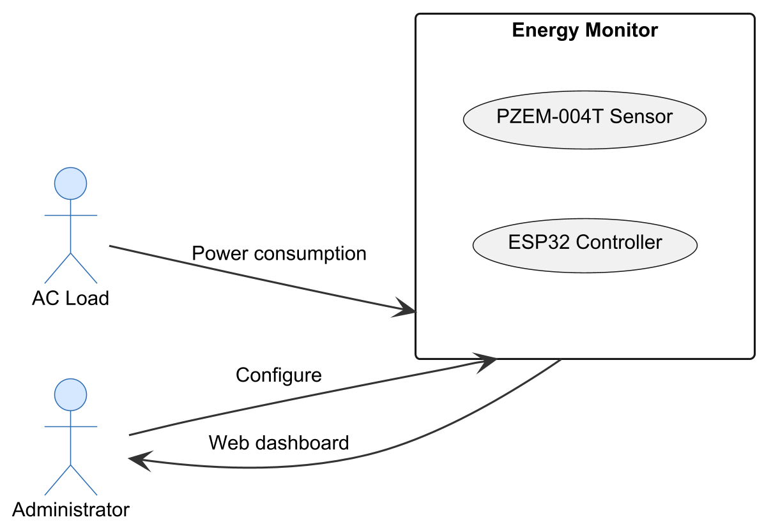
Figure 2.15: Structural Model of ESP32 + PZEM-004T
Behavioural Model: The ESP32 polls the PZEM-004T every few seconds and forwards readings to the server. The server stores and displays the data.
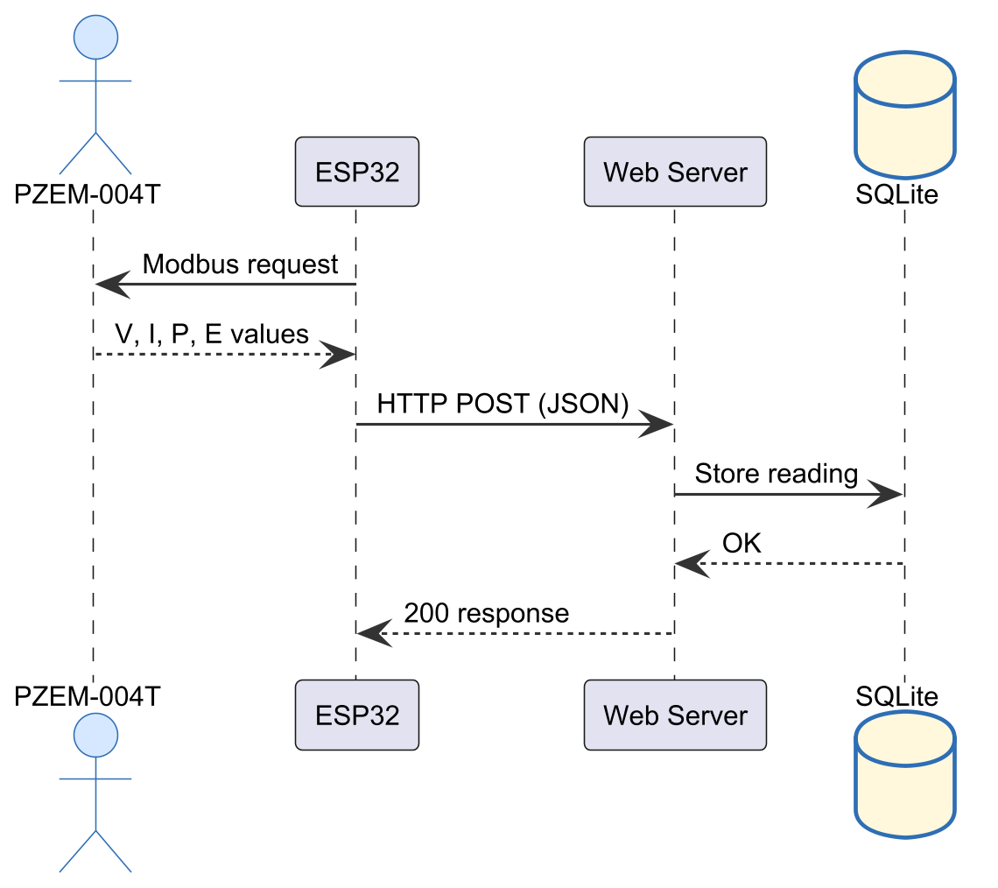
Figure 2.16: Behavioural Model of ESP32 + PZEM-004T
1. DESCRIPTION OF SYSTEM (Features of the system):
Real hardware — measures actual electrical parameters
Low-cost components (approx. $15 total)
Open-source firmware (Arduino IDE)
Measures 6 electrical parameters
Development tools and environment: Arduino IDE, C/C++, Modbus library, ESP32 board package.
2. REVIEW OF THE GOOD FEATURES
Real hardware — actual energy measurements
Very low cost
Well-documented — large community of users
Can be expanded to multi-point monitoring
3. REVIEW OF THE BAD FEATURES
Requires electrical wiring — safety concerns
Modbus communication can be unreliable over long wires
No built-in dashboard — must be built separately
Limited to indoor use (no weatherproofing)
4. SUMMARY OF THE SYSTEM REVIEW: The ESP32 + PZEM-004T combination is an excellent low-cost real-world energy monitoring solution. However, it requires hardware assembly, electrical wiring, and is not suitable as a pure software simulation for educational purposes.
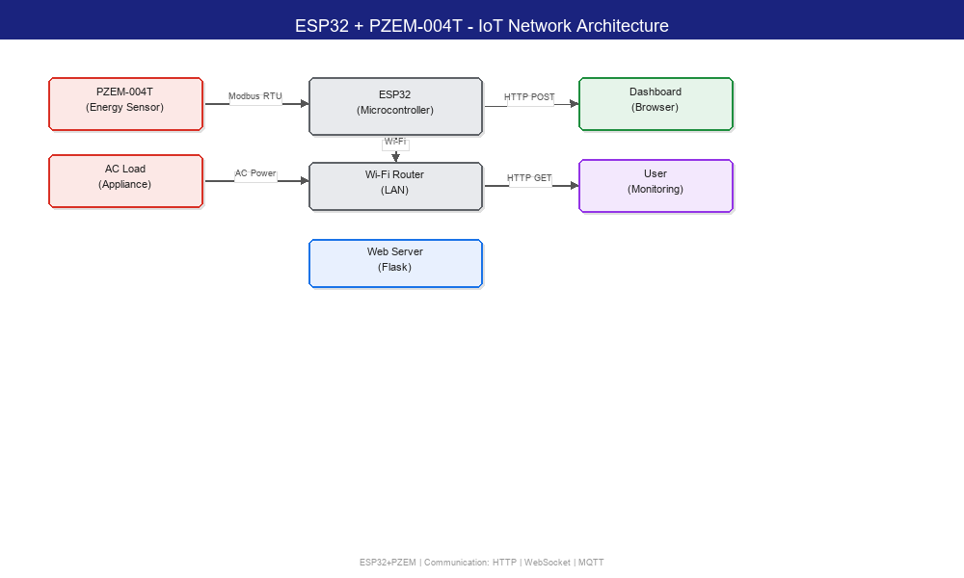
Figure 2.20: ESP32 + PZEM-004T - IoT Network Architecture

